# User Input

## Question: 1

How would I collect a number from the user to use for the radius of a circle?

int(input(“What is the radius?: “))

radius = int(“What is the radius?: “)

radius = int(input(“What is the radius?: “))

radius = int input(“What is the radius?: “)

## Question: 2

What is the correct way to ask a user for a color and store the answer as a variable?

color = input(“Give a color: “)

user_color = “Give a color: ”

input(“Give a color: “)

user_color = input(“Give a color: “)

## Question: 3

The name ‘color’ cannot be used for our variable because:

Variable names cannot only be 1 word

The word ‘color’ is already used as a Tracy command

The word ‘color’ needs to be capitalized to be used as a variable name

Variable names must include underscores

# Parameters

## Question: 1

Why are parameters useful?

They allow us to tailor functions to be used in multiple situations

They allow us to change the order of commands in a function

They give us the ability to use variables in loops

They allow the user to give input

## Question: 2

How many parameters can we use in each function?

1

2

4

As many as we need

## Question: 3

What is the best way to write a program that uses parameters to draw a square with sides that are 50 pixels long?

1. 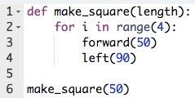
2. 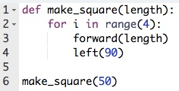
3. 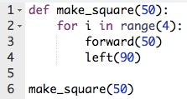
4. 